Business Question and Visualization Report

Date | 18 September 2026
Team ID | MCA
Project Name | Online Learning Engagement and Student Performance Analysis
Maximum Marks | 5 Marks
Visualization development is the process of showing data using charts, graphs, tables, and dashboards. It makes large or complex data easier to understand and helps users quickly find important information, patterns, and trends. The process includes selecting the right type of chart, arranging the visual elements clearly, and adding interactive features when needed. This makes the data easier to explore and understand. Visualization development is widely used in business intelligence, data analysis, and reporting. It helps users understand data clearly and make better decisions based on the information.
Business Questions and Visualisation
The process starts by identifying specific business questions that help guide the development of useful visualizations in Power BI. Clear questions help determine which data, metrics, and charts should be used. This ensures that the visualizations provide meaningful insights and support better understanding and decision-making.
What is the distribution of final student results? | Donut chart showing Pass, Fail, Withdrawn, and Distinction results. | 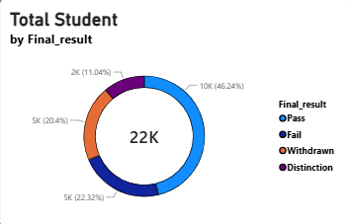
 | Clustered bar chart showing total students by region. | 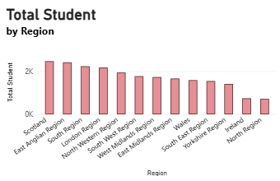
  Which regions have the highest number of student records?
 | Clustered column chart showing average score by education level | 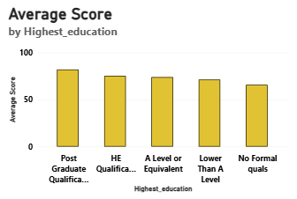
  How does average score vary by highest education level?
What is the relationship between engagement level and average total clicks? | Column chart showing average total clicks by engagement level. | 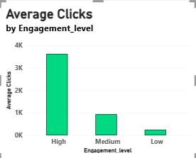
Which risk level has the highest dropout rate? | Bar chart showing dropout rate by risk level. | 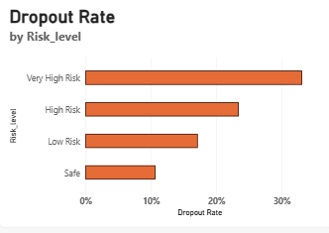
How does performance level differ by gender? | Stacked column chart showing performance-level distribution by gender | 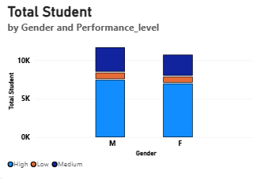
How are final results distributed across engagement levels? | Decomposition table showing final result by engagement level. | 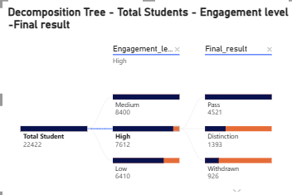
What is the overall average score? | KPI CARD | 